KATARINA CEHOVSKI

1. List all data for jobs sorted in ascending order of max salary.

SELECT * FROM Jobs ORDER BY Max_Salary ASC

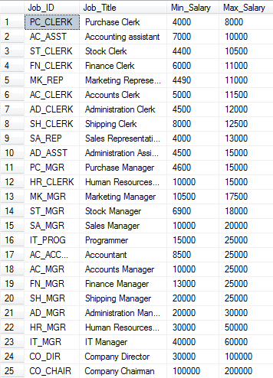

1. List first and last name, job and salary of employees hired after 1999 with salary >=7000 descending from first name.

SELECT First_Name, Last_Name, Annual_Salary, Job_Title FROM Employees, Jobs WHERE Hire_Date> '1999' and Annual_Salary>= 7000 and Jobs.Job_ID= Employees.Job_ID ORDER BY First_Name DESC

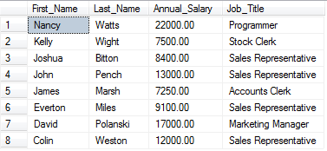

1. List all data from jobs sorted in ascending order of Job_ID.

SELECT * FROM Jobs ORDER BY Job_ID ASC

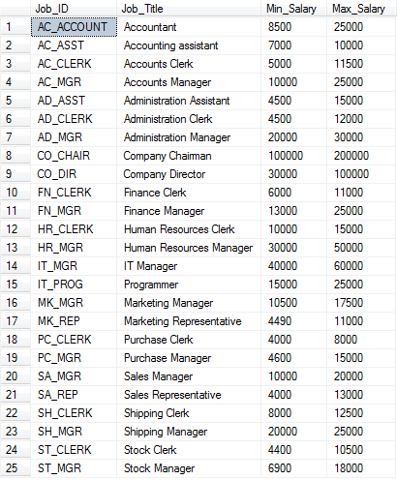

1. a) Update all the maximum salaries for jobs with an increase of 2000.

UPDATE Jobs SET Max_Salary += 2000

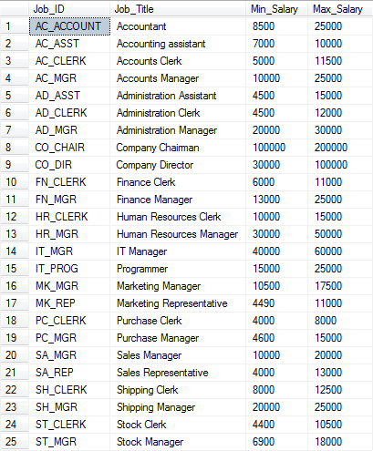

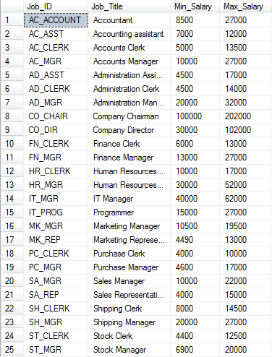

b) The job history for employee number 122 is no longer required. Delete this record.

DELETE FROM Job_History WHERE Employee_No = 122

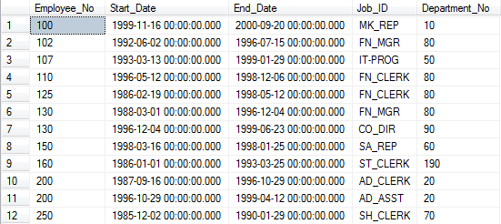

1. Add the following new job into jobs AC-ASST, Accounting assistant, 7000, 10000.

INSERT INTO Jobs VALUES ('AC_ASST','Accounting assistant', 7000, 10000)

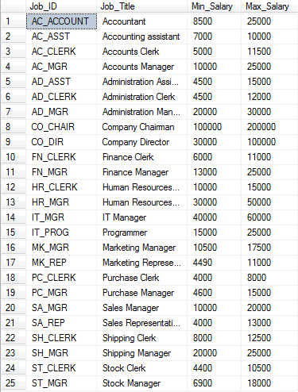

1. List first name, last name, employee number of sales reps hired after the 15 dec 1997 in ascending order by last name.

SELECT First_Name, Last_Name, Employee_No FROM Employees WHERE Job_ID= 'SA_REP' and Hire_Date >= '1997-12-15' ORDER BY Last_Name ASC

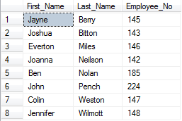

1. List the last name, first name and Job_ID of employee where commission earned is greater or equal to 25% sorted in ascending order by last name.

SELECT Last_Name, First_Name, Job_ID FROM Employees WHERE Commission_Percent>= 0.25 ORDER BY Last_Name ASC

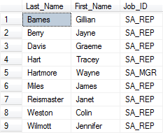

1. List department number, last name and salary of employees who were hired between 26/08/1998 and 16/11/1999 sorted in descending order of last name.

SELECT Department_No, Last_Name, Annual_Salary from Employees WHERE Hire_Date BETWEEN '1998-08-26' and '1999-11-16' ORDER BY Last_Name ASC

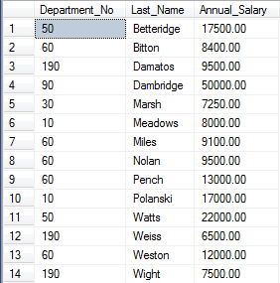

1. List all the data for jobs sorted in ascending order of Job_ID.

SELECT * FROM Jobs ORDER BY Job_ID DESC

